1.While traversing a single circular linked list the last element must be pointed to the first element in other words the last node must contain the address of the first element of the linked list. So that the iteration is completed all over the linked list .

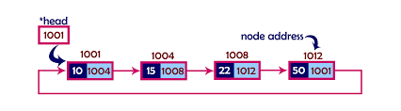

2. The practical applications of linked doubly list are:

-In multiplayer games all the players are in a circular linked list that's why when a player make a movement it occurs in the others player screen also.

-In our laptops we use to open a lot of tabs at a same time and all these are tabs are able to run on the same time with the help of the single linked list and the operating system gives the appropriate time slot for the processing and the operating system kept on iterating over the linked list until all the applications are completed.